Apr 30 Research

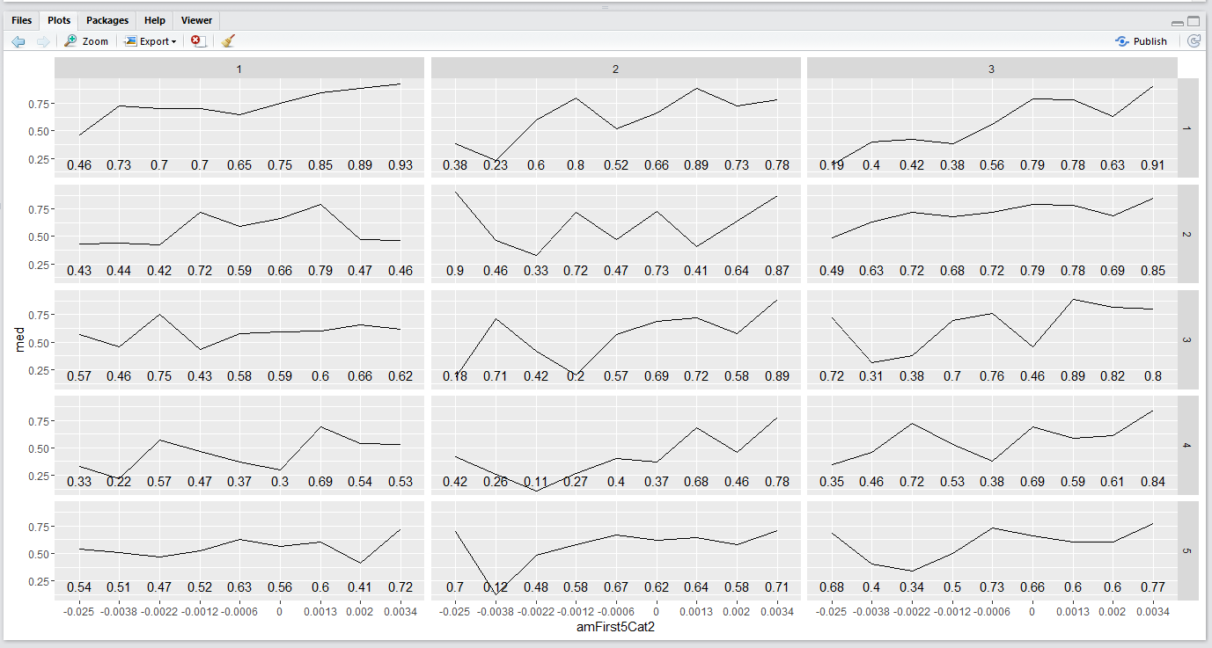

X axis: amFirst5 categories.

Y axis: weekday.

Aes: median of closing percentile.

Label: median of closing percentile.

(2)

x: amClosePercentileCat

Y: weekday

Fill: amFirst5>0.

aes: ending percentile

This plot is weekday by amFirst5Cat, annotating the median of ending percentile.

The relationship between amFirst5 and ending percentile is more linear on the upside.

One can see that on tue, wed, fri ( in that order), the closing percentile tends to rise in the afternoon.

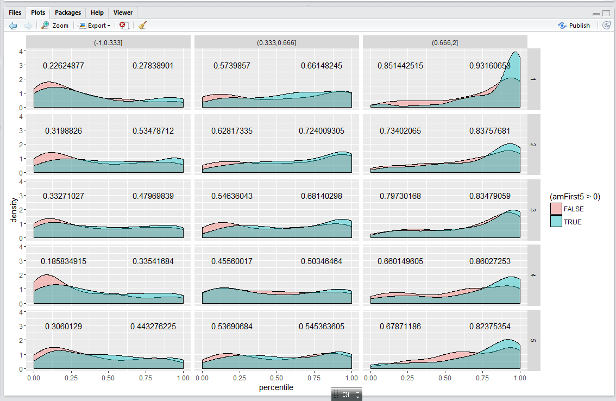

weekday+amClosePercentileCat.

This set of plot examines the scenario how amClosePercentile affects closePercentile, conditional on weekday and amFirst5. In terms of rebound strength, tue>wed>fri>thu>mon.

It can be seen how strongly the effect amFirst5 has on the distribution of percentile.

the labels are median pm return in each of the scenarios. One can see that on Tuesday and Wednesday, the return is positive regardless of amFirst5. This means holding on wed and Tue is justified. Mistakes have been made cutting position in wed PM resulting in losses.

